IB DP Geography –Types of Volcanoes

We will be focusing on the three kinds of volcanoes; shield, composite and cinder. Complete the worksheet below.

Feature | Shield Volcano | Composite Volcano | Cinder Volcano
Diagram | 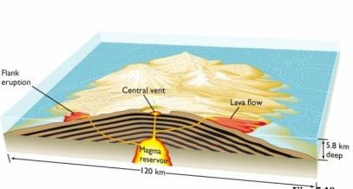 | 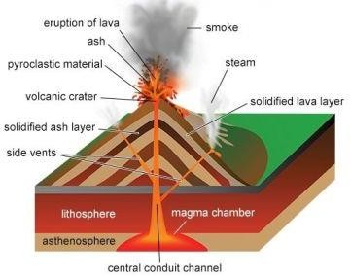 | 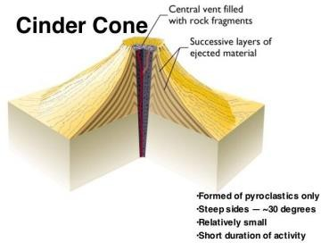
Description of Shape
Link shape to characteristics of lava emitted
Type of eruption (sudden, violent etc.)
Example Place

