Reducing Disparities
Trade and Market access

Part 1:
What is trade & why is it important?
What is a Trading Bloc?
Give examples of different trading blocs & their aims (include images)
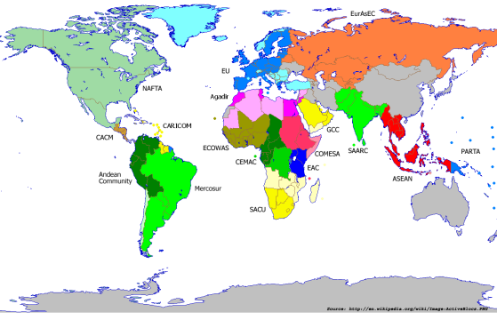
Trading relationship between MEDC / LEDC’s

Part 2 (Case study on FairTrade):
Introduction to Fairtrade
What it hopes to achieve
How does it work?
How can it promote a reduction in disparities between countries?
What is a trade barrier?
How can this prevent fair trade?
Case study example: Bananas
Evaluation of the Fair-trade strategy. Is it working? Will it continue to work? What more needs to be done?

