Tropical Rainforests of the World
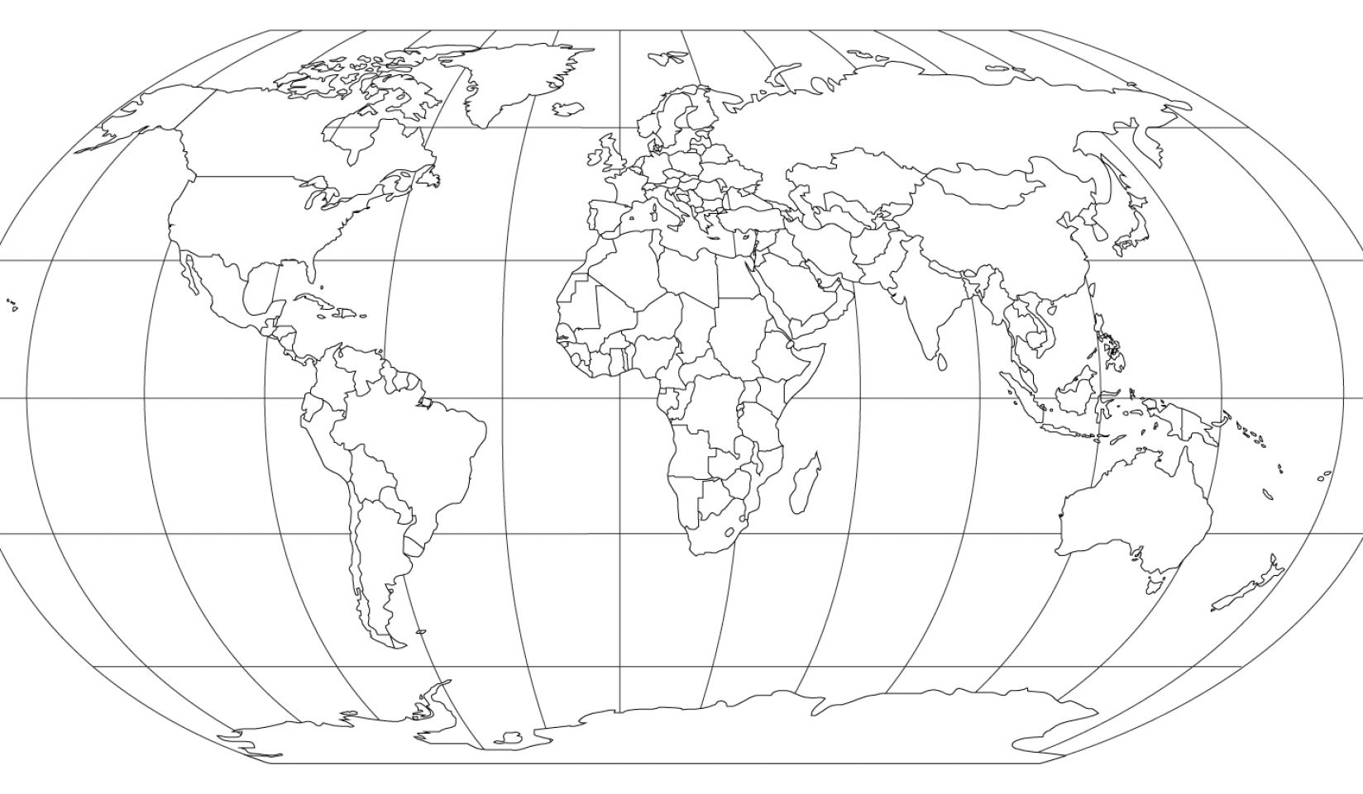
Task 1: Shade in the Rainforests of the world of the world and label them
Task 2: Describe their distribution.
___________________________________________________________________________________________________________________________________________________________________________________________________________________________________________________________________________________________________________________________________________________________________________________________________________________________________________________________________________________________________________________________________

