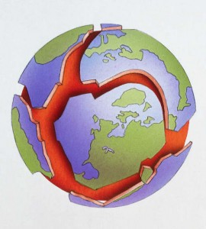

**Plate Tectonics**

What are Tectonic Plates?

_________________________________________________________________________________________________________________________________________________________________________________________________________________________________________________________________________

What is the Theory of Plate Tectonics?

_________________________________________________________________________________________________________________________________________________________________________________________________________________________________________________________________________

Using a diagram explain how and why plates move.

___________________________________________________________________________________________________________________________________________________________________________________________________________________________________________________________________________________________________________________________________________________________________________________



sing a diagram explain how and why plates move._______________________________________________________________________________