This line of **latitude** is called the Tropic of Antarctic Circl .

It is 66.5 degrees sout of the equator. . .

This line of **latitude** is called the Antarctic Circle .

It is 66.5 degrees sout south hhhh of the equator. .equator ..

This line of **longitude** is called the .

Name:

Mapping lines of latitude and longitude

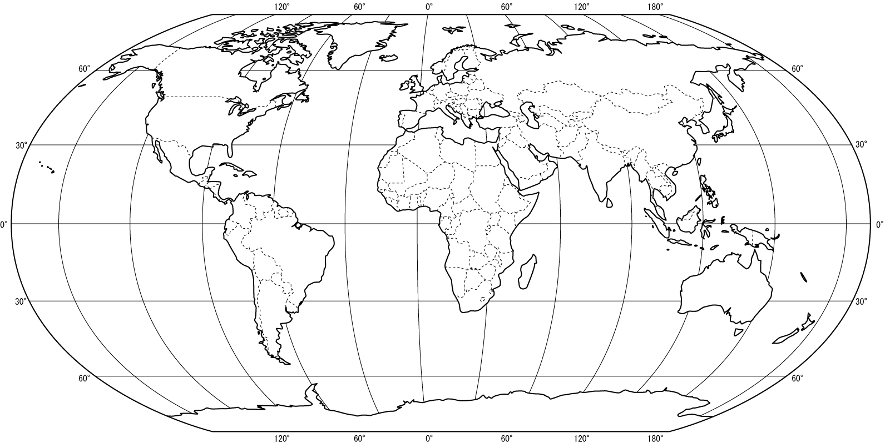

This line of **latitude** is called the equator

This line of **latitude** is called the Tropic of

quator . It is degrees of the .

This line of **latitude** is called the Antarctic Circle .

It is 66.5 degrees sout of the equator. ..

Geographers use maps to find out where places are and what they are lie. An atlas is a book that has maps showing places all around the world, and it is easy to use. The most accurate way to show the whole world is on a globe. This is because a globe, being round, shows the actual shape of the earth.

To help us find places, imaginary lines called **latitude** and **longitude** are drawn on the globe.

Lines of **latitude** are imaginary lines going around the globe from **east to west**. They are measured in degrees north or south of the **Equator.** Latitude 0º is called the Equator.

Lines of **longitude** are imaginary lines going from the **North Pole to the South Pole**. They are measured from the **Greenwich Meridian**, which passes through London. The Greenwich Meridian is 0º