Introduction to Oceans
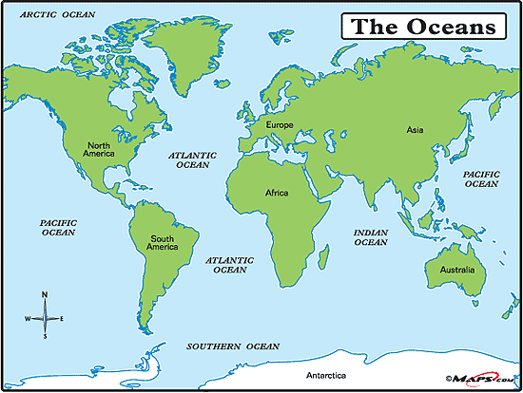

Averages
- Temperature: Below 1000m there is a uniform average of 2°C
- Salinity: 35 parts per thousand (ppt)

