Debt relief - Reducing Disparities
What is debt relief?
- Usually when a person who owes money(debtor) is forgiven partially or completely , and no longer needs to pay their debt.

Though depending on the situation it can be:
- Reduced
- Refinanced
- Reorganized
- Rescheduled
- Cancelled

Which countries are most in debt? By how much?
- The countries that are most in debt are: (USD)
CORE:
- United States ($15,940,978,000,000)
- United Kingdom ($9,307,090,000,000)
- Germany ($5,539,282,000,000)
- France ($5,303,543,000,000)
- Japan ($2,826,649,000,000)
PERIPHERY:
- Argentina
- South Africa
- Nigeria

The core countries are very much so in debt, however this debt has little impact on the core countries as a number of contributing factors (for example, other countries owe them more than the amount of debt they owe) allowing them to easily pay off this debt if they wanted to. On the other hand, it is quite difficult for the periphery countries to pay off this debt as they do not have sufficient financial resources or financial stability.

Why is LEDC debt such a problem?
- Biggest reason for the issue: Periphery countries owe a lot of money to the core countries.
Certain countries are pressuring the periphery countries to sacrifice the little that they’ve progressed in such as: spending for education, health and to prioritize on repaying their debt.
The core countries don’t realize that for the periphery countries these repayment figures are a matter of life and death while for them it’s simply “tiny”.

- For the poorest countries debts to multilateral institutions is around $70 billion.
- The are some multilateral that agreed upon cancelling or relief for the poorest countries to pay their debt, though these “promises” and “agreements” have either not taken place or are going at a very slow rate for cancellation.
How can debt reduction help to solve the disparity between countries?

- The imbalance between countries will improve, becoming less of a “gap”, if there’s debt reduction because if > both debtor and creditor agree on reducing the amount of money that is suppose to be payed. They reduce the balance and will then consider that as the full payment instead.
s
Case Study: Live8
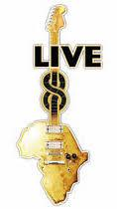
What is Live8?
- The Live 8 Concert:
  - A series of benefit concerts.
    - Largest entertainment event in history.
    - Took less than 100 days to execute after the idea was conceived.
  - Organised to link with the G8 summit.
    - This was originally organized by the G8 in order to to help the world’s poorest countries.
      - So that they may stabilize and grow economically.
- The concerts took place on July 2nd 2005 in:
  - London, Philadelphia, Paris, Berlin, Rome, Barrie, Tokyo, Johannesburg, Cornwall, Edinburgh and Moscow.
  - 10 million people attended the concerts and around 3 Billion saw the broadcasts.

- Some of the 1000 celebrities that supported this were:
  - Bill Gates, Bono, Elton John, Paul McCartney, Snoop Dogg, Sting, Kanye, Jay Z & Magic System.

What was its purpose?
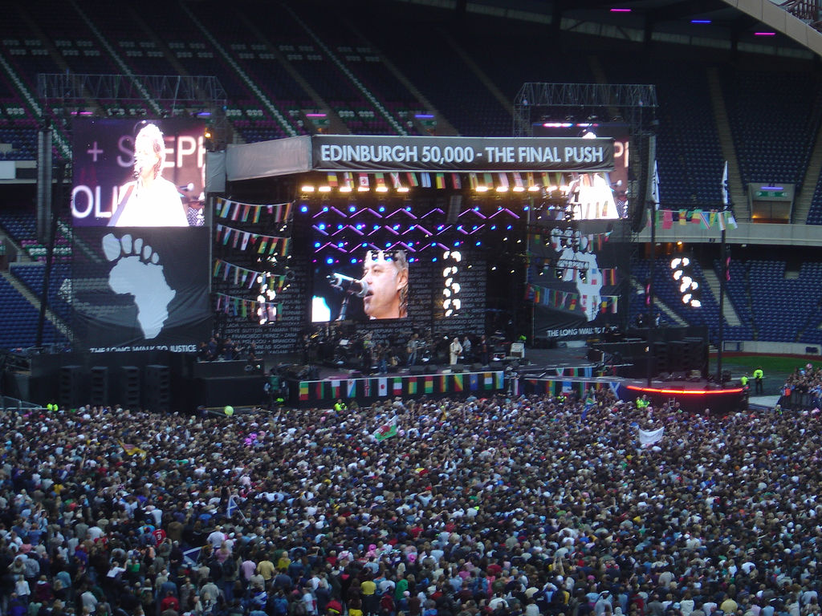
  - Half of all the concerts’ earnings went to African countries.
    - The money would help reduce by 100% the debt owed by the World’s poorest countries to the World’s richest countries.
  - The concert also aimed to:
    - Add high quality aid.
    - Alter the trade laws in order to help the countries build a future for themselves.
    - Save over 1 million lives.
    - Raise awareness.
    - Reduce disparities between countries.

Who is Bob Geldof?
He is an Irish singer and songwriter, author and political activist.
He is known especially as anti-poverty efforts concerning Africa.
- Benefactor singer
- in July 2005, Geldof organized "Live 8" charity pop concerts that were timed to coincide with the G8 summit on world poverty, held in Perthshire, Scotland. In support of the Make Poverty History campaign, performances were broadcast in 10 cities around the world
- Member of the Africa Progress Panel (a group of ten distinguished individuals who advocate at the highest levels for equitable and sustainable development in Africa)
- Every year, the APP releases a report and outlines an issue of immediate importance to the Africa and suggests a set of associated policies.
- His aim was to increase the pressure on the summit to ratchet up aid and debt relief for Africa

Who are the G8?

The group of seven (G7, formerly known as G8) are a group of governmental forums of leading advanced economies in the world. The forum originated with a 1975 summit hosted by France that brought together representatives of six governments: France, West Germany,Italy, Japan, the United Kingdom, and the United States, thus leading to the name Group of Six or G6. The summit became known as the Group of Seven or G7 in 1976 with the addition of Canada.

What were the outcomes of the Live8 campaign?

- The G8 Summit ended on July 8, 2005 and the leaders pledged to increase aid to developing countries by US$50 billion overall by 2010, including an increase of US$25 billion in aid for Africa.
- Today, the goals have not been met and have fallen short by US$19 billion
- However, Thirty-five countries have had their debt cancelled to the tune of US$35.5 billion, helping Zambia to provide universal healthcare, and countries such as Uganda, Ghana, Malawi and Tanzania to abolish fees for primary school
- The G8 promised to secure an “ambitious and balanced conclusion to the Doha Round” which sought to make trade work for Africa.
- The broad failure to create a better trade environment for African countries is one of the most clearly missed Gleneagles commitments.
- However, aid for trade to sub-Saharan Africa has almost doubled since 2005

8 years later on in 2013, have all promises been kept?
The Promise: Debt cancellation for 38 countries over time, starting with 18 immediately
- The G8 have met their first commitment on this, cancelling the debt of 18 countries in 2006.

The Promise: Every child in school by 2015.
- THe situation is better, but additional funds should be found.( 21 million more children)
G8 leaders promised to increase annual aid to poor countries by $50bn and to Africa by $25bn by 2010
- only $19bn help total , ( 11 to africa)

