Global Energy Budget
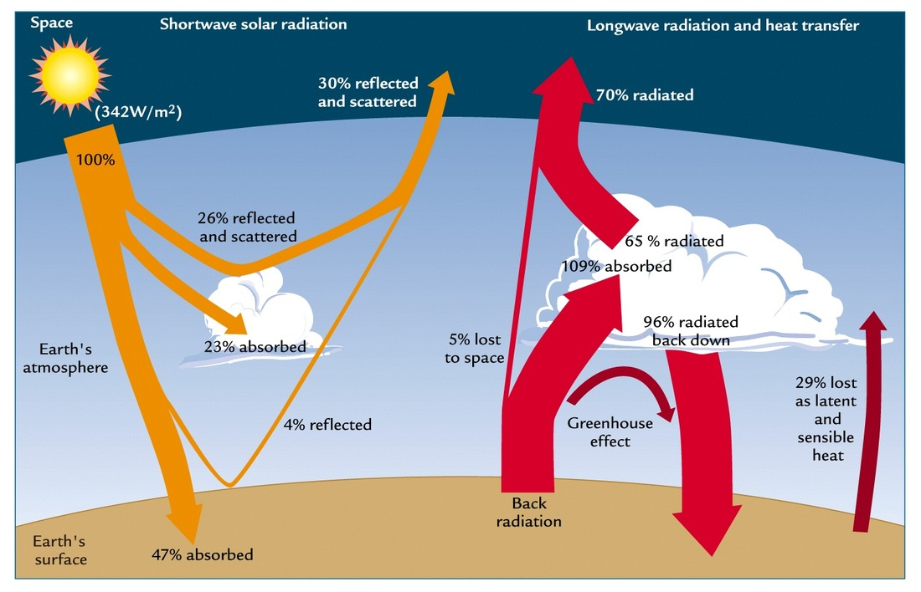

Explain the atmospheric energy budget (use the website and also page pg. 53 of the IB book 'Course Companion')
____________________________________________________________________________________________________________________________________________________________________________________________________________________________________________________________________________________________________________________________________________________________________________________________________________________________________

What is external forcing? (give examples)
____________________________________________________________________________________________________________________________________________________________________________________________________________________________________________________________________________________________________________________________________________________________________________________________________________________________________

What is Global Dimming and what causes it? (link to albedo)
What impacts does it have on the world
________________________________________________________________________________________________________________________________________________________________________________________________________________________________________________________________________________________________________________________________________________________________________________________________________________________________________________________________________________________________________________________________________________________________________________________________________________________

