**Factors that determine the site of a Settlement**

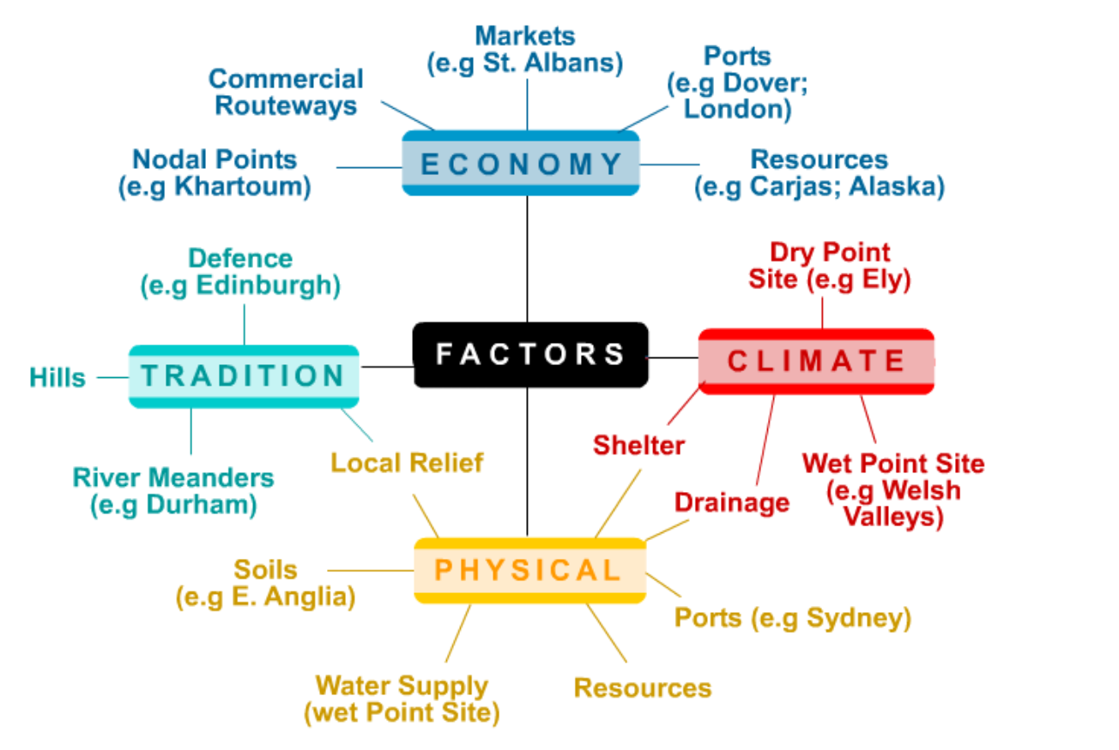

*Explain how and why these factors influence the site of a settlement?*

*___________________________________________________________________________________________________________________________________________________________________________________________________________________________________________________________________________________________________________________________________________________________________________________________________________________________________________________________________________________________________________________________________________________________________________________________________________________________________________________________________________________________________________________________________________________________________________________________________________________________________*