Types of River Delta
River Deltas
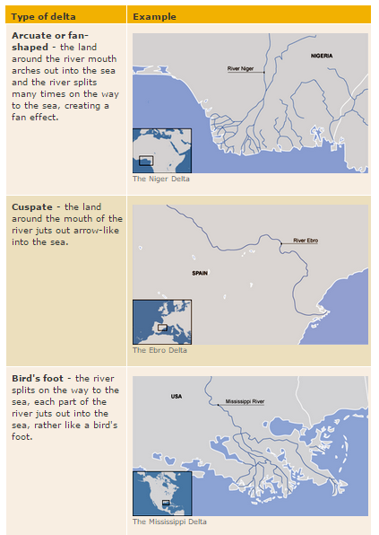
Explain how river deltas are formed
_____________________________________________________________________________________________________________________________________________________________________________________________________________________________________________________________________________________________________________________________________________________________________________________________________________________________

