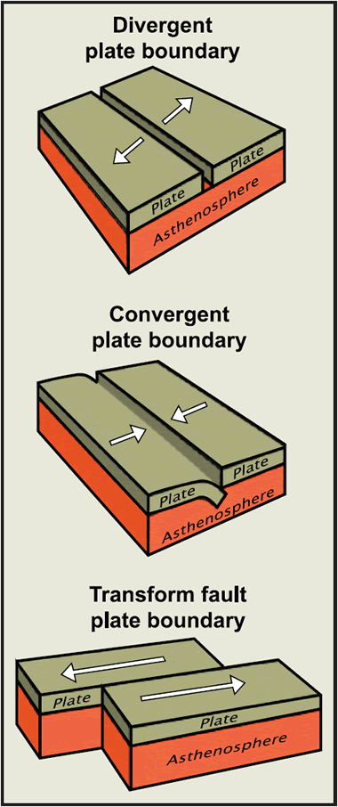
Tectonic Plate Boundaries – Worksheet.
Draw each plate boundary and write an explanation of what is happening at each diagram. Use the numbers to help you order your ideas.
Constructive Plate Boundary

Constructive Plate Boundary
- ____________________________________________________________________________________________________________________________________________________________________________________
- ____________________________________________________________________________________________________________________________________________________________________________________
- ____________________________________________________________________________________________________________________________________________________________________________________
- ____________________________________________________________________________________________________________________________________________________________________________________
- ____________________________________________________________________________________________________________________________________________________________________________________

Destructive Plate Boundary

- ____________________________________________________________________________________________________________________________________________________________________________________
- ____________________________________________________________________________________________________________________________________________________________________________________
- ____________________________________________________________________________________________________________________________________________________________________________________
- ____________________________________________________________________________________________________________________________________________________________________________________
- ____________________________________________________________________________________________________________________________________________________________________________________
- ____________________________________________________________________________________________________________________________________________________________________________________
- ____________________________________________________________________________________________________________________________________________________________________________________

Collisional Plate Boundary

- ____________________________________________________________________________________________________________________________________________________________________________________
- ____________________________________________________________________________________________________________________________________________________________________________________
- ____________________________________________________________________________________________________________________________________________________________________________________
- ____________________________________________________________________________________________________________________________________________________________________________________
- ____________________________________________________________________________________________________________________________________________________________________________________

Conservative Plate Boundary

- ____________________________________________________________________________________________________________________________________________________________________________________
- ____________________________________________________________________________________________________________________________________________________________________________________
- ____________________________________________________________________________________________________________________________________________________________________________________
- ____________________________________________________________________________________________________________________________________________________________________________________
- ____________________________________________________________________________________________________________________________________________________________________________________
- ____________________________________________________________________________________________________________________________________________________________________________________

