Write an explanation of what is happening at each of the Plate Boundary Diagrams. Use the numbers to help you order your ideas.
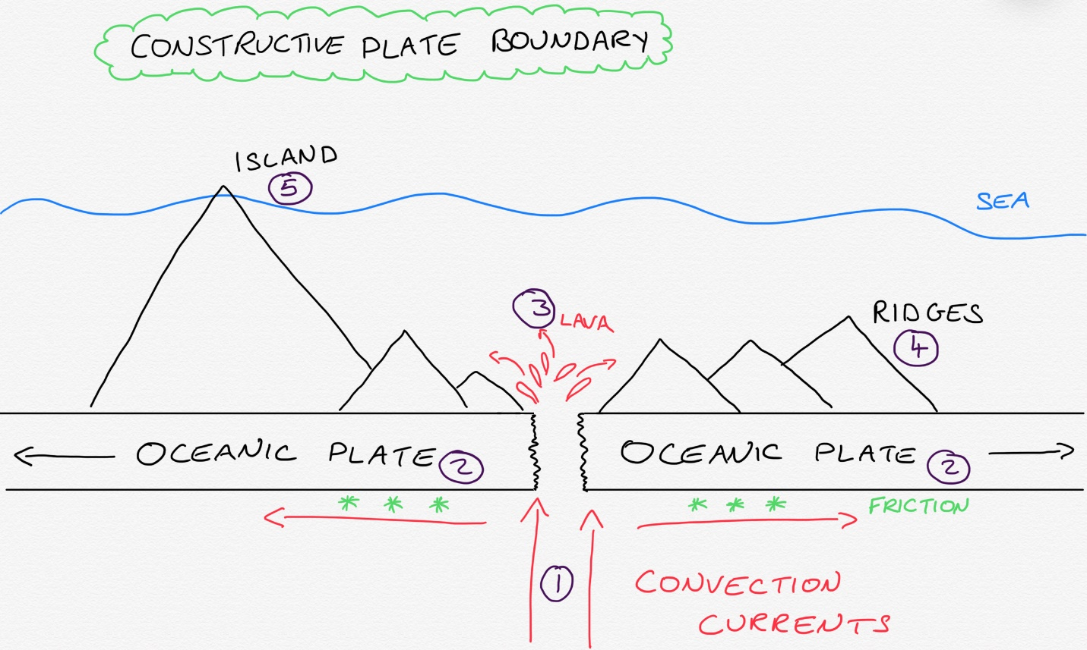
- Convection currents in the Mantle rise upwards towards the crust.
- As they push left and right the friction between them and the Oceanic Plates drag the plates away from each other. (Divergent movement)
- Underwater volcanoes erupt lava out of the gap that is generated in the sear floor.
- The lava builds up to for under water mountains called Ridges.
- These Ridges can sometimes grow to become islands like the Azores in the Atlantic Ocean.
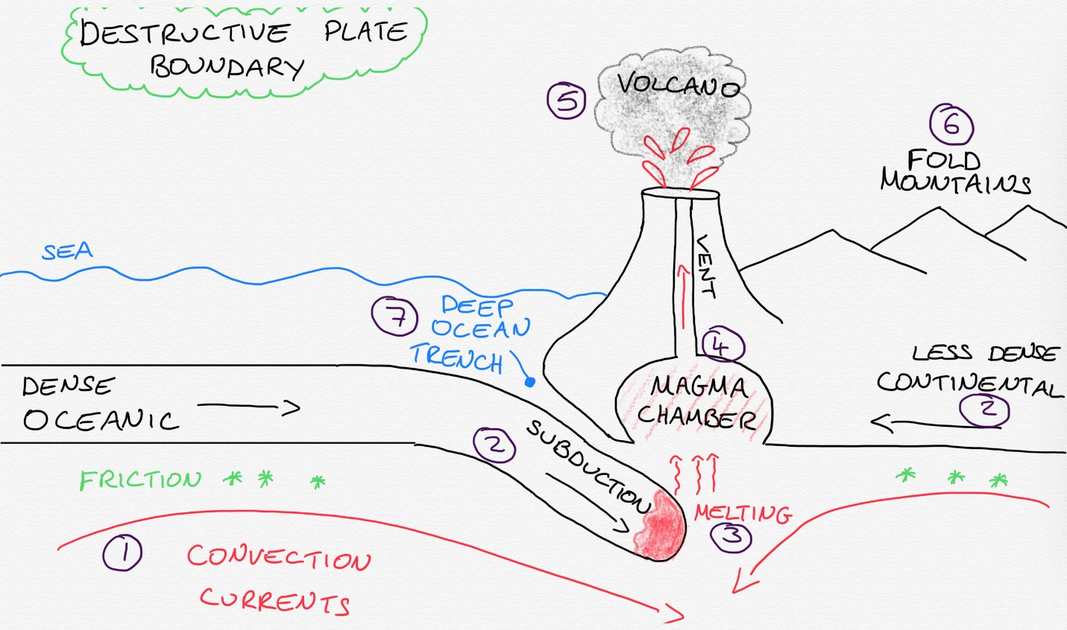
- Convection currents in the Mantle move towards each other and sink back to the Core.
- The friction generated between these convection currents and the tectonic plates move them towards each other. The more dense Oceanic plate is subducted under the less dense Continental plate.
- The subducted plate melts due to the heat and extreme pressure.
- The melted magma can rise and form a Magma Chamber.
- As the Magma Chamber grows it builds pressure that can be released in a volcanic eruption.
- The collision of the two plates stresses the plates which can bend/fold creating Fold Mountains.
- Where the two plates meet in the ocean they can create a Deep Ocean Trench. These are some of the deepest points on our planet.
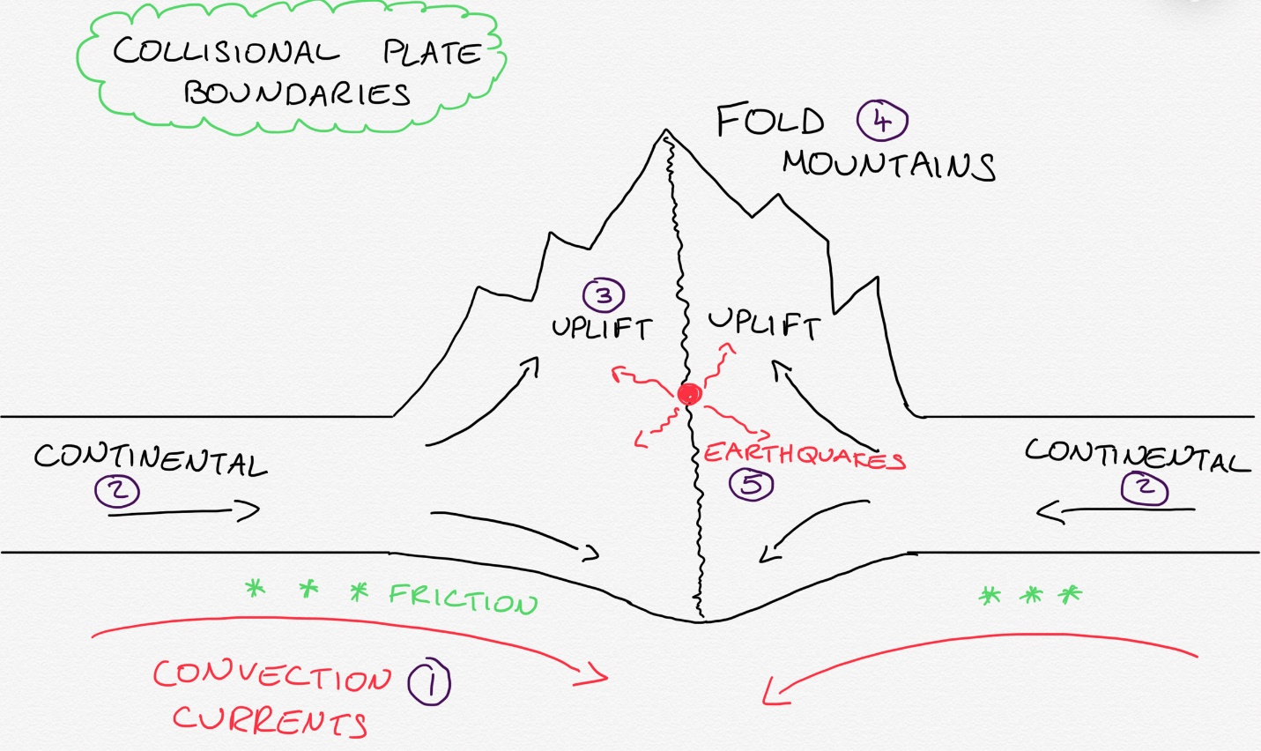
- Convection currents in the Mantle move towards each other and will drag the plates above them in the same direction through friction.
- For a collisional boundary to form both plates need to have the same density. E.g. Continental and Continental.
- The colliding plate boundaries of equal density push together and start to lift upwards.
- This uplift slowly creates large Fold mountain ranges.
- Collisional plate boundaries build up huge tectonic pressure that can be released in violent Earthquakes.
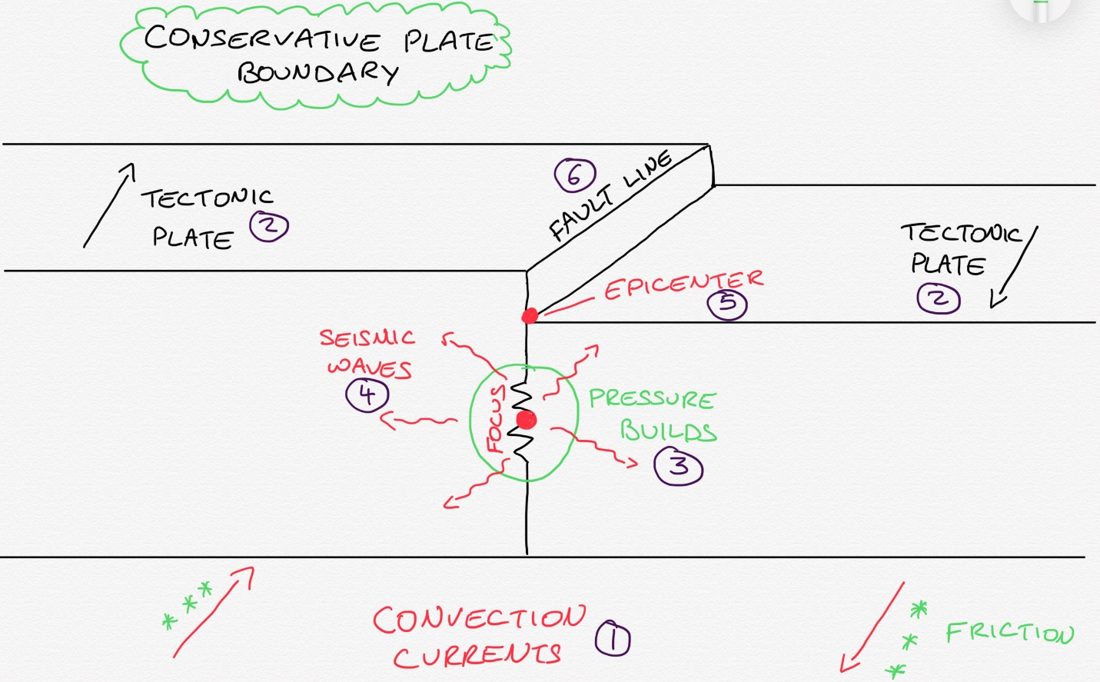
- Convection currents in the Mantle can move side by side creating friction that drags the plates in a Transform movement.
- This plate boundary can occur with all plate types.
- Where the plates meet they can ‘lock’ together and build up extreme pressure.
- Eventually these plates will ‘slip’ or move suddenly releasing energy in the form of Seismic waves that emanate from the Focus.
- On the surface the area directly above the focus is called an epicenter.
- Conservative plate boundaries can form long/deep faults that run along the boundary E.g. The San Andreas Fault in California.

