Pebble Size
Location: La Gravette (Managed beach)
Measurement
 | Site A  Medium Axis |  | Site B  Medium Axis |  | Site C  Medium Axis
 | 1st | 2nd | 1st | 2nd | 1st | 2nd
1
2
3
4
5
6
7
8
9
10
11
12
13
14
15

Measurements are taken in cm – You will be recording the largest pebble that is found in the top left quadrat and in the bottom right quadrat.
Pebble Size
Location: La Joliette (Unmanaged beach)
Measurement
 | Site A  Medium Axis |  | Site B  Medium Axis |  | Site C  Medium Axis
 | 1st | 2nd | 1st | 2nd | 1st | 2nd
1
2
3
4
5
6
7
8
9
10
11
12
13
14
15

Measurements are taken in cm – You will be recording the largest pebble that is found in the top left quadrat and in the bottom right quadrat.

Pebble Roundness
Location: La Gravette (Managed beach)
Measurement
 | Site A |  | Site B |  | Site C
 | 1st | 2nd | 1st | 2nd | 1st | 2nd
1
2
3
4
5
6
7
8
9
10
11
12
13
14
15

Pebble Roundness
Location: La Joliette (Unmanaged beach)
Measurement
 | Site A |  | Site B |  | Site C
 | 1st | 2nd | 1st | 2nd | 1st | 2nd
1
2
3
4
5
6
7
8
9
10
11
12
13
14
15

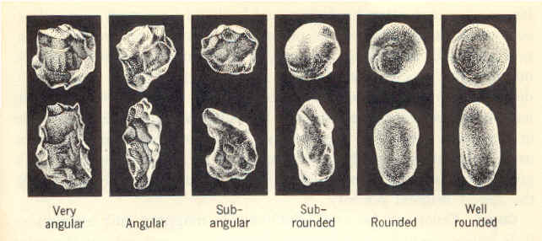
1 | 2 | 3 | 4 | 5 | 6

Index taken from:
http://www.earthstudies.co.uk/Geography/Individual%20Research%20in%20Geography%20G3/Powers%20Scale%20of%20Roundness.html

