Peak Oil – Geopolitical Impacts of Oil Production
Notes: Oil Production.
IB Geography March 2013
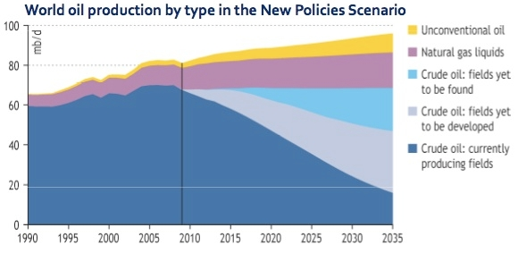

- According to this graph, what year was peak Crude Oil extraction reached?

- Describe the best case scenario for the continued use of Crude Oil between now and 2035

Hubbert’s Peak Graph
Video Notes Continued

