IB Geography – Hazards & Disasters
Case Study Summary Sheet for Haiti Earthquake 2010 (LIC) Where did it happen?

Haiti is located in the Caribbean Sea, south east of Cuba and is part of the island originally called Hispaniola. It shares a border with the Dominican Republic and the capital city is Port au Prince. Haiti regularly suffers from considerable natural disasters being located on a major tectonic plate boundary but also in the path of some of the most violent hurricanes that sweep in from the Atlantic Ocean every year. In fact, in 2008, Hurricane Gustav ravaged the island destroying 3000 houses, damaging nearly 12,000 and killing nearly 80 people. Haiti was still re-building phase when it was hit by the great quake of 2010. The quake struck approximately 25 km WSW from Port-au-Prince at a depth of 13 km. Over 2 million Haitians live in Port au Prince and it is the most densely population area of the country.

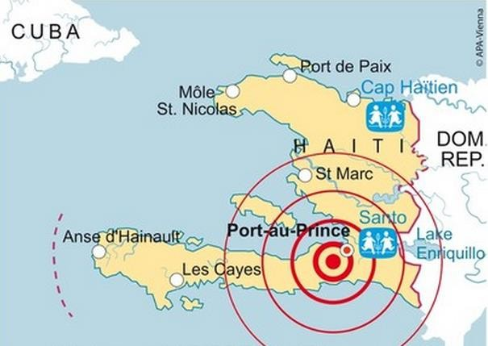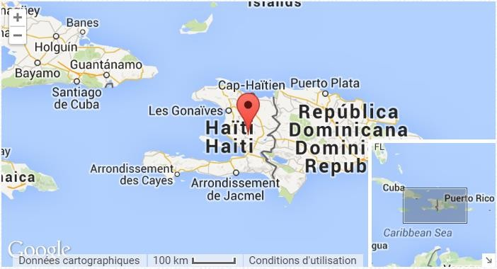

CIA Fact Box – Haiti Need To Know

Indicator Values (2010 estimated)
GDP per capita PPP $1300
People Living in Poverty (less than $2 per day) 80% of the population Access to Clean Water 46% of the population Life Expectancy 63 years
Literacy Rate 48.7%
People Per Doctor 0.25 doctors per 1000 people

When did it happen?

Date. Tuesday 12 January 2010

Time (local). 16.53

Duration. A matter of seconds but in the proceeding 12 days, a total of 52 aftershocks were recorded each further weakening and damaging infrastructure.

The earthquake happened in the late afternoon meaning that populations were spread out in risky areas (workplace, home, transportation). No foreshocks had been recorded and no advanced warning had been given of the forthcoming earthquake event.

Why did it happen?

Strong shaking associated with intensity IX on the Modified Mercalli scale (MM) was recorded in Port-au-Prince and its suburbs. It was also felt in several surrounding countries and regions. According to estimates from the United States Geological Survey, approximately 3.5 million people lived in the area that experienced shaking intensity of MM 7 to 10, a range that can cause moderate to very heavy damage even to earthquake-resistant structures. Shaking damage was more severe than for other quakes of similar magnitude due to the shallow depth of the quake.

The quake occurred in the vicinity of the northern boundary where the Caribbean tectonic plate shifts eastwards by about 20 mm (0.79 in) per year in relation to the North American plate. The January 2010 quake was caused by a rupture of the Enriquillo-Plantain Garden fault, which had been locked for 250 years, gathering stress.

Who was affected by it happening?

Social Impacts Economic Impacts
3 million people in total affected.

Over 220,000 deaths caused by the collapsing buildings, a small tsunami and the cholera epidemic in the proceeding weeks. The resulting sanitation problems have increased cases of dysentery, malaria and drug-resistant tuberculosis

300,000 injured and treatment difficult due to several hospitals collapsing and the death and displacement of medical staff in and around Port au Prince.

1.3 million People made homeless due to collapsed or partially collapsed and unsafe housing.
30,000 commercial buildings collapsed leading to a loss of trade and income for the already crippled economy.

Businesses destroyed and vast sums of money for the rebuilding process – money that Haiti did not have.

Damage to the main clothing industry.

Airport and port damaged so damage to imports and exports as well as a slowdown in the rescue and response from overseas.

Environmental Impacts Political Impacts
Deforestation and forest clearance to make way for temporary camps and for building materials.

Small scale pollution by the leakage of oil and other chemicals into the surrounding environment due to the rupture and damage to industrial facilities.

Pollution of water supply leading to cholera epidemic.
Appeals for international aid were immediately requested by Raymond Joseph, Haiti's ambassador to the United States and his nephew, singer Wyclef Jean. The American Red Cross quickly announced that it had run out of supplies in Haiti and appealed for public donations.

Haiti’s justice system remains in disarray with very few of those arrested in the past year having been brought before a judge at all, let alone within 48 hours of arrest as required by Haitian law
Impacts of these hazards on different aspects of human well-being
Health Shelter

Food Water

Why levels of vulnerability varied both between and within communities

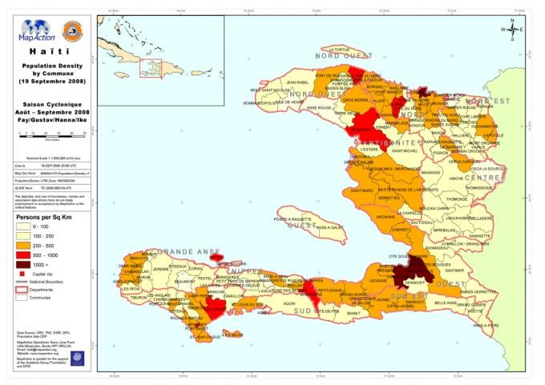

Comment on the spatial distribution of population density in Haiti (2008 – two years before the quake).

Map to show the epicentre and intensity of shaking during the 2010 Earthquake Event.
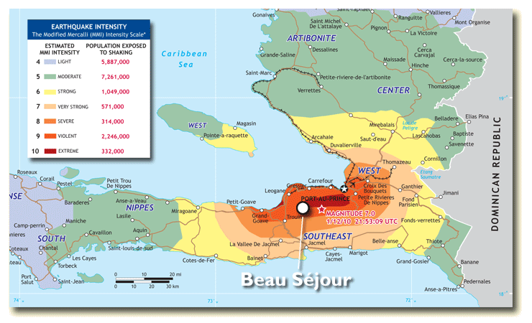

Comment on the relationship between the epicentre of the earthquake and the number of people exposed to severe
– extreme shaking. Take a note of the total number of people affected in this category.

Comment on the relationship between the epicentre of the earthquake and population density of the country.

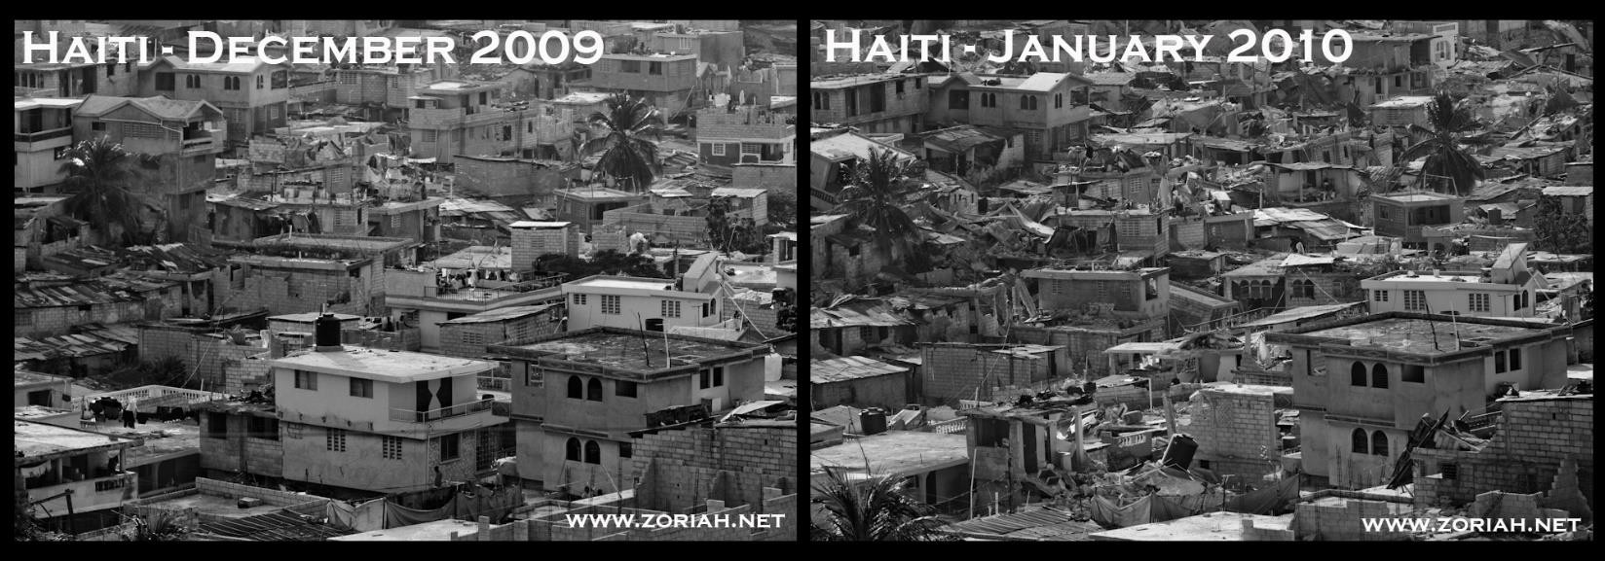

Study the image above carefully. A higher quality zoom image can be found here. Explain how building design and distribution could have increased levels of vulnerability in Port Au Prince.

The levels of poverty in Haiti coupled with successive natural disasters (hurricanes and earthquakes) meant that Haitians were not prepared for a disaster on this scale. Explain what proactive measures are being put into place to reduce vulnerability and improve preparednes

