Global Population Density
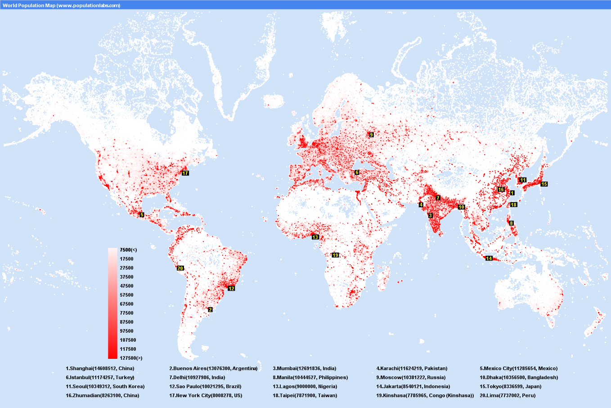

Describe the global population density [3]
___________________________________________________________________________________________________________________________________________________________________________________________________________________________________________________________________________________________________________________________________________________________________________________________________________________________________________________________________________________________________________________________________________________________________________________________________________________________

