Case Study for:
- Patterns in Environmental Quality and Sustainability (core 3)
- Oceans and their coastal margins – Sustainable fishing (optional unit)
Environmental sustainability (definition) = A state in which the demands placed on the environment can be met without reducing its capacity to allow all people to live well, now and in the future.

Canada – Sustainable Fisheries Management
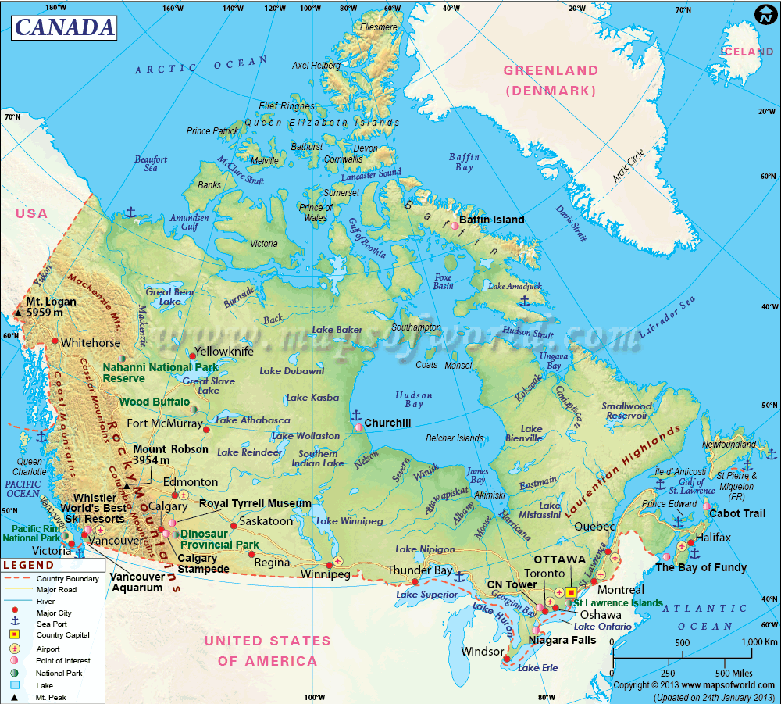

Timeline of events
1960s | 1970s | 1980s | 1990s
Canada’s fishing industry still severely underdeveloped | Huge growth and development. | Continued growth and the beginning of regulatory policies | Sections of fishing industry at a position of over capacity/collapse. Huge regulatory measures imposed

Overview of the problem
Atlantic:  - Main fish stock is the groundfish, cod and shellfish (lobster mainly)  - The fishing industry is of more importance to the overall economy – there is a large regional specialization of the type of fishing and on fishing as an industry.  - From 1980 to the late 1990s commercial catches of all fish stocks halves (1.6 million metric tons to 850,000)  - Overfishing and climate change (ocean temperatures and nutrition levels fell)  - But – Shellfish productivity rose (lower ocean temperatures beneficial) | Pacific:  - Main commercial fish: Samon but not as important to the areas industry as a whole.  - Poor environmental conditions (climate change) caused a fall in 80% of total captures.  - Now restrictions and competition from Chile and Norway have negated Salmon fishing as a commercial industry.

Solutions:
Individual quotas | Ability to select individual fisheries and corporations. Easy to administer and ensures that only the reputable organisations gain access to fishing rights – much better than a blanket quota for all fishermen.
Unemployment insurance | Fisherman’s unemployment insurance: aimed at reducing the reliance on fishing and diversifying to other sectors of the industry. Reduced total fishermen numbers
Aboriginal participation | An exception was made on aboriginal peoples so as to continue with their fishing activities for self-sustainability.
Oceans to plate policy | Co-operation with fisheries and aquacultures. Development of ‘Eco labels’ and certifying products that come from sustainable fisheries
Limited entry licensing | Increasingly hard for ‘new’ fishing companies to enter the market – effectively having a finite license number means that companies need to compete for the license.

Outcome (Sustainable or not?)
Overall: No – the Canadian fisheries still suffer from various problems:  - Natural resource variability  - Common property nature of fisheries  - Market fluctuations  - Conflicting interests between all stakeholders  - Over reliance on fishing and limited alternative choices  Ground fish stocks have failed to recover over the last 15 years, Pacific salmon stocks are still low as are cod stocks.  The initiative has been expensive $4 billion and if not for the abundance of shellfish this government assistance would not have been enough. | Successes:  The situation has been stabilized, it is not getting worse  Certain fish stocks have recovered: Halibut and sablefish

Note: To achieve sustainability on such a large scale is very hard. Canada has recognized the problem and is trying to resolve it. This is the first stage in a long processes.

