Year 10 Geography

ENERGY

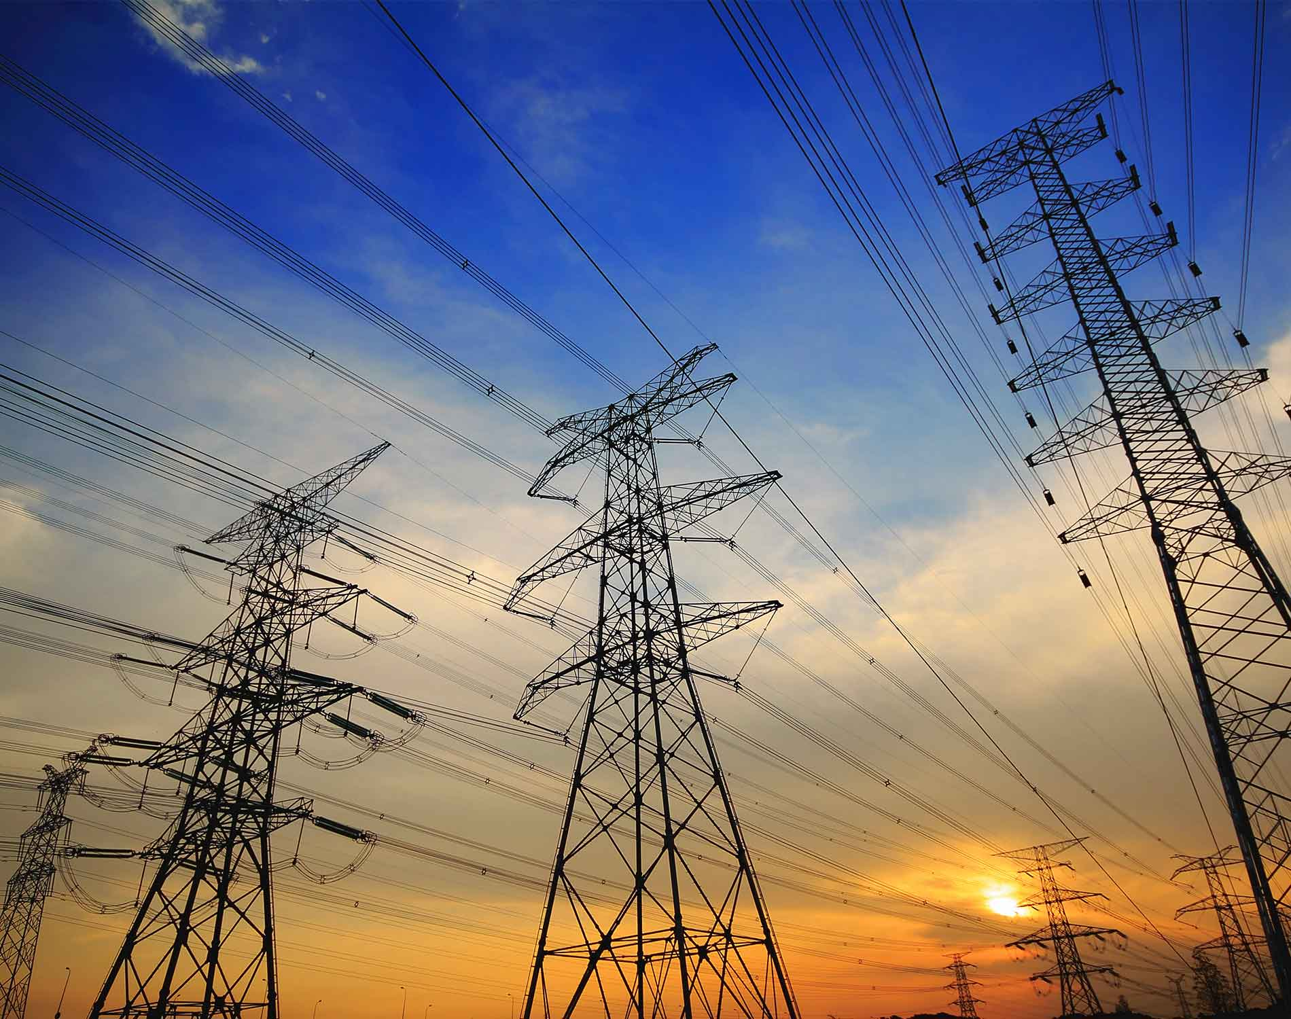

NAME:

…………………………………………………………….

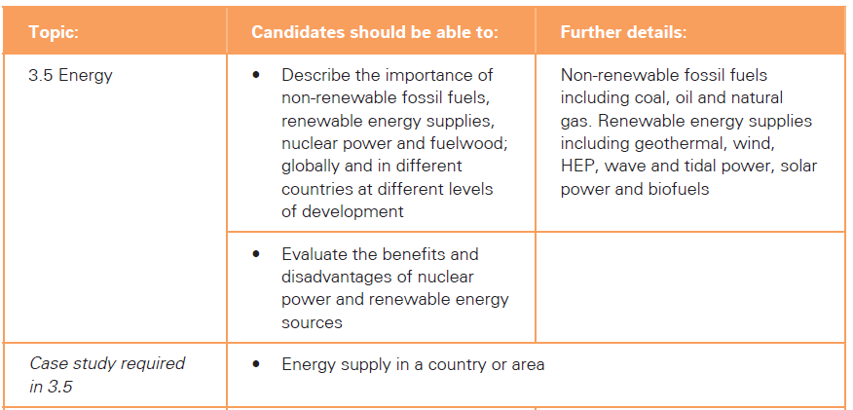

What Are Resources?

Define the following terms

|  |  |
| --- | --- |
| Term | Definition |
| Natural resources |  |
| Human resources |  |
| Non-renewable resources |  |
| Renewable resources |  |
| Sustainable development |  |

Complete the spider diagram with the consumption of different types of fuel (p.208)

Consumption by type of fuel

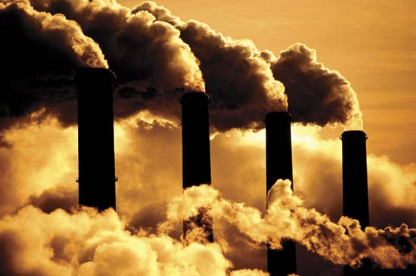

Define: fossil fuels (p.207)

………………………………………………………………………………………………………………

………………………………………………………………………………………………………………

Name the three fossil fuels

a)…………………………………………

b)…………………………………………

c)…………………………………………

Complete the table on the next page and put the following types of energy in the non-renewable or renewable section of the table.

* Coal
* Geothermal Power
* Wind power
* Oil
* Solar Energy
* Natural Gas
* Hydrogen
* Tidal
* Nuclear
* Waves
* Biomass
* Fuelwood
* Hydroelectric power

|  |  |
| --- | --- |
| Non-renewable | Renewable |
|  |  |
|  |  |
|  |  |
|  |  |
|  |  |
|  |  |
|  |  |
|  |  |

ADVANTAGES AND DISADVANTAGES OF OIL

|  |  |
| --- | --- |
| Advantages of Oil | Disadvantages of Oil |
| 1 | 1 |
| 2 | 2 |
| 3 | 3 |
| 4 | 4 |

Explain what happened in the 2010 Gulf of Mexico Oil Spill and the environmental effects of this disaster.

What happened?

………………………………………………………………………………………………………………

………………………………………………………………………………………………………………

………………………………………………………………………………………………………………

………………………………………………………………………………………………………………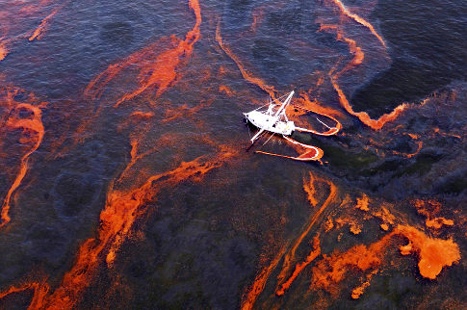

Environmental implications:

………………………………………………………………………………………………………………

………………………………………………………………………………………………………………

………………………………………………………………………………………………………………

………………………………………………………………………………………………………………

………………………………………………………………………………………………………………

………………………………………………………………………………………………………………

………………………………………………………………………………………………………………

Where are thermal power stations (using coal, oil or gas) located and why?

* Near the coast - because.……………………………………........................................

…………………………………………………………………………………………………………..

* Large areas of cheap land – because …………………………………………………….

…………………………………………………………………………………………………………..

* Near coal fields (if coal fired) – because ………………………………………………..

……………………………………………………………………………………………………………..

* Good rail or road networks – because ……………………………………………………

……………………………………………………………………………………………………………..

* Away from places with large numbers of people - because…………………………

……………………………………………………………………………………………………………..

NUCLEAR POWER



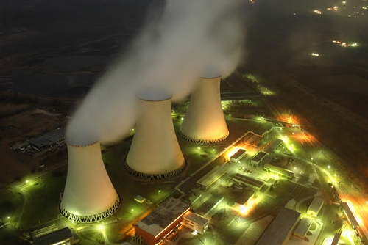

Nuclear energy is the solution? (p.210)

|  |  |
| --- | --- |
| Advantages | Disadvantages |
|  |  |
|  |  |
|  |  |
|  |  |
|  |  |
|  |  |
|  |  |
|  |  |

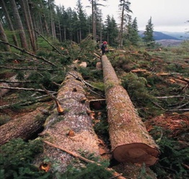

FUELWOOD

What is fuel wood and what problems can it cause?

(pg. 209)

………………………………………………………………………………………………………………………………………………………………………………………………………………………………………………………………………………………………………………………………………………………………………………………………………………………………………………………………

………………………………………………………………………………………………………………

………………………………………………………………………………………………………………

HYDROELECTRIC POWER pg 211

Name three countries that get a lot of power from HEP:

* 1 ………………………………….
* 2 ………………………………….
* 3 ………………………………….

List the advantages and disadvantages of HEP

|  |  |
| --- | --- |
| Advantages of HEP | Disadvantages of HEP |
| 1 | 1 |
| 2 | 2 |
| 3 | 3 |
| 4 | 4 |
| 5 | 5 |
| 6 | 6 |
|  | 7 |
|  | 8 |

But HEP also has some disadvantages…….

GEOTHERMAL ENERGY (p 213)

What is geothermal energy?

……………………………………………………………………………………………………………..

……………………………………………………………………………………………………………..

Which countries use a lot of geothermal energy?

……………………………………………………………………………………………………………..

……………………………………………………………………………………………………………..

What four advantages does geothermal energy have?

1……………………………………………………………………………………………………………..

2……………………………………………………………………………………………………………..

3……………………………………………………………………………………………………………..

4…………………………………………………………………………………………………………….

What four disadvantages are there of using geothermal energy?

1……………………………………………………………………………………………………………..

2……………………………………………………………………………………………………………..

3……………………………………………………………………………………………………………..

4……………………………………………………………………………………………………………..

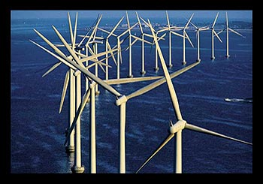WIND pg 212

Name some countries using a lot of wind power.

Where are wind turbines generally located to be efficient?

………………………………………………………………………………………………………………

………………………………………………………………………………………………………………

………………………………………………………………………………………………………………

………………………………………………………………………………………………………………

Why should governments be encouraging the use of wind power?

There are many advantages of using wind power……………………………………………….

………………………………………………………………………………………………………………

………………………………………………………………………………………………………………

………………………………………………………………………………………………………………

………………………………………………………………………………………………………………

………………………………………………………………………………………………………………

………………………………………………………………………………………………………………

………………………………………………………………………………………………………………

………………………………………………………………………………………………………………

Why do some governments not feel inclined to use wind power?

Some governments feel that the disadvantages outweigh the advantages………………..

………………………………………………………………………………………………………………

………………………………………………………………………………………………………………

………………………………………………………………………………………………………………

………………………………………………………………………………………………………………

………………………………………………………………………………………………………………

………………………………………………………………………………………………………………

………………………………………………………………………………………………………………

………………………………………………………………………………………………………………

SOLAR ENERGY (p 214)

How is solar energy generated?

………………………………………………………………………………………………………………

………………………………………………………………………………………………………………

………………………………………………………………………………………………………………

………………………………………………………………………………………………………………

Why is it unsuitable for countries like Britain?

………………………………………………………………………………………………………………

………………………………………………………………………………………………………………

………………………………………………………………………………………………………………

Why are some scientists looking to encourage solar power use in the future?

………………………………………………………………………………………………………………

………………………………………………………………………………………………………………

………………………………………………………………………………………………………………

………………………………………………………………………………………………………………

BIOFUELS (p. 212)

Why are Biofuels considered to be a renewable energy resource?

………………………………………………………………………………………………………………………………………………………………………………………………………………………………………………………………………………………………………………………………………………………………………………………………………………………………………………………………………………………………………………………………………………………………………………………………………………………………………………………………………………………………

Why does GreenPeace and other environmental organisations no longer support Biofuels?

………………………………………………………………………………………………………………………………………………………………………………………………………………………………………………………………………………………………………………………………………………………………………………………………………………………………………………………………………………………………………………………………………………………………………………………………………………………………………………………………………………………………………………………………………………………………………………………………………………

TIDAL AND WAVE POWER (p.214)

How does the coast have the potential to generate electricity?

………………………………………………………………………………………………………………………………………………………………………………………………………………………………………………………………………………………………………………………………………………………………………………………………………………………………………………………………………………………………………………………………………………………………………………

Case Study: Create a set of case study notes on Energy supply in China (p.215)

