**Mangrove Swamps**

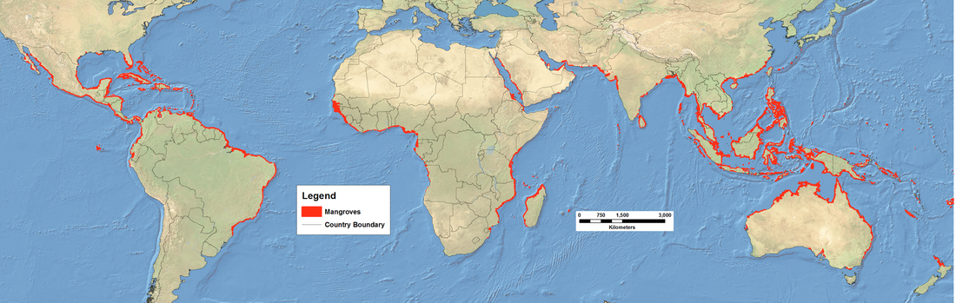

**What conditions are needed for Mangroves to form (why do they form)?**

**Describe the distribution of Mangrove Swamps in the world.**