Hot Deserts of the World
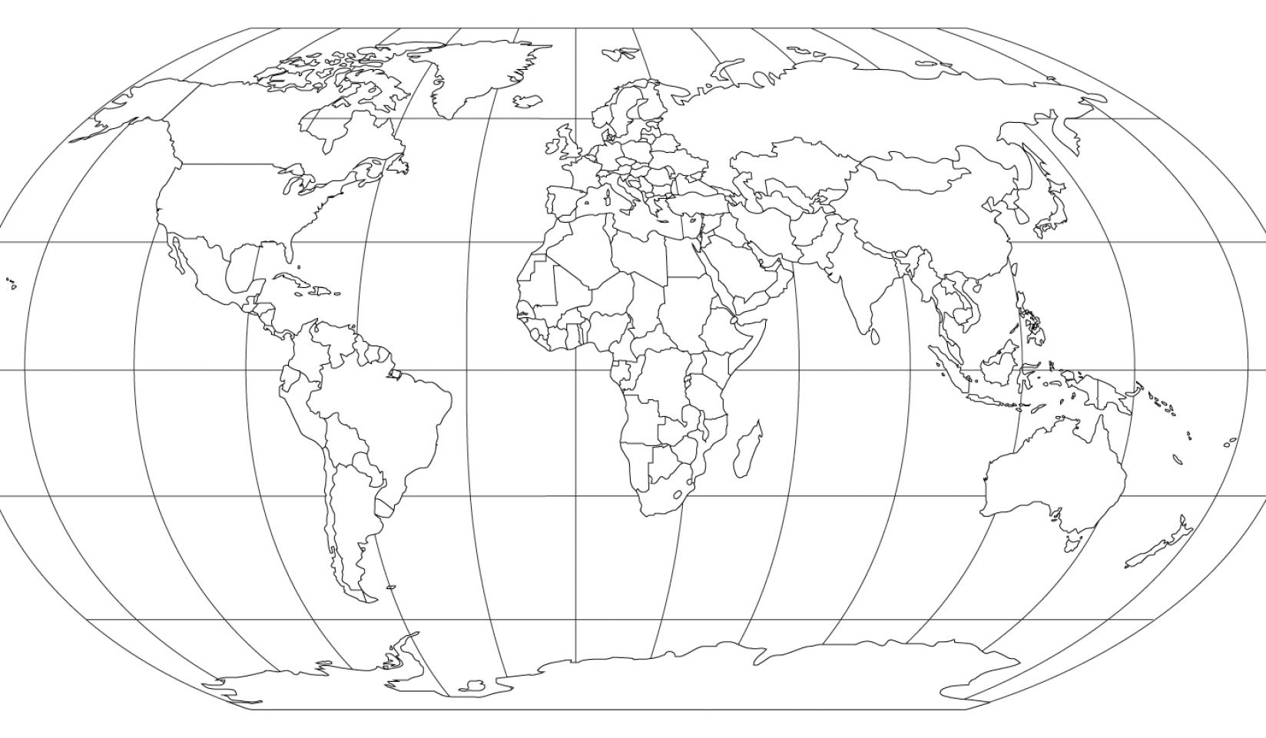
Task 1: Shade in the deserts of the world and label them
Task 2: Describe their distribution.
___________________________________________________________________________________________________________________________________________________________________________________________________________________________________________________________________________________________________________________________________________________________________________________________________________________________________________________________________________________________________________________________________

