Dams and Reservoirs
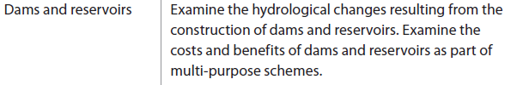

How would a dam affect the normal drainage basin cycle?

Why are dams and Reservoirs constructed?

Make a list of all the benefits and costs of Dams and Reservoirs. Link to real life examples
(note these down in a different colour)
Benefits | Costs

