The Global shift – the car industry.

A global shift is when industry_________________________________ from one part of the

world to ______________________________. There are many reasons why TNCs choose to do

this. The main reason is to increase p________________________ and p_____________________.

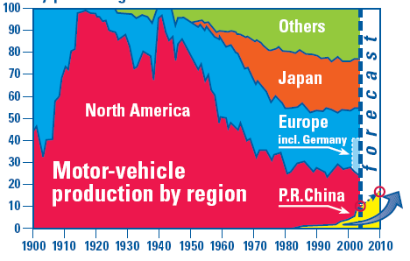

This graph shows that _________________________used to produce most of world’s cars. In

19________production was at it highest and North America produced __________% of all

the world’s cars. Due to competition mainly from____________________ and

___________________ its production has started to ___________________. From 1990 the

graph shows that ______________________is starting to_________________________.

WORD BANK

- China
- Moves
- Profit
- 1920
- Increase car production
- Japan
- Another
- Production
- 99%
- North America
- Europe
The Global shift – the car industry.

A global shift is when industry_________________________________ from one part of the

world to ______________________________. There are many reasons why TNCs choose to do

this. The main reason is to increase p________________________ and p_____________________.

This graph shows that _________________________used to produce most of world’s cars. In

19________production was at it highest and North America produced __________% of all

the world’s cars. Due to competition mainly from____________________ and

___________________ its production has started to ___________________. From 1990 the

graph shows that ______________________is starting to_________________________.

WORD BANK

- China
- moves
- profit
- 1920
- increase car production
- Japan
- another
- production
- 99%
- North America
- Europe

