Y7: Why do settlements start?
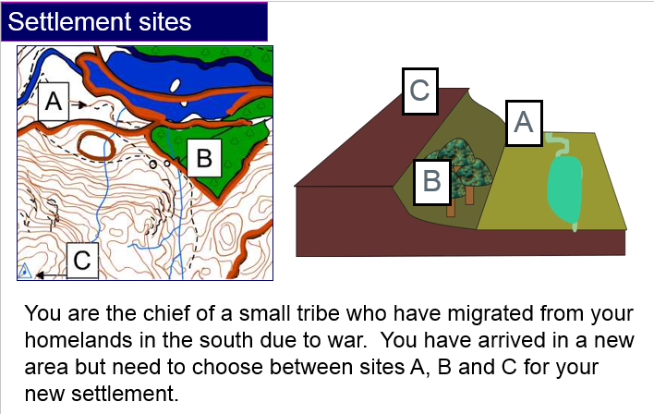
- What site have you chosen?
______________________________________________________________________________________________________________________________________________________

- Explain why.
____________________________________________________________________________________________________________________________________________________________________________________________________________________________________________________________________________________________________________

- Look at the figure below showing settlement sites A – E.
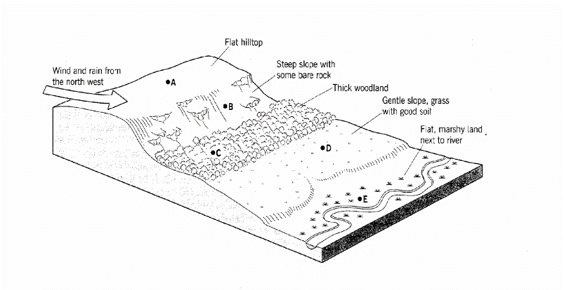
Describe the advantages and disadvantages of settling at each of sites A – E.
Site | Advantages | Disadvantages
A
B
C
D
E

Good and bad places to settle!

The diagram you have been given shows the location of five different settlement sites. Using the statements in the table below, decide what the advantages and disadvantages are for ONE of the five sites. Write them in the respective advantages / disadvantages column on the other handout with the diagram.

Advantages

Access to river  Easy to cross by foot at a ford or by bridge | Shelter  On a south facing slope there is more sun and shelter from the north wind | Dry Site  Must not flood easily or be marshy | Fresh water  Either from a river or spring for drinking, cooking and washing
Good soil  Fertile and well drained, away from the floodplain | Building Materials  Be near a wood or rocky hillside for wood and stone. | Flat land  Easy to build on and grow crops | Defensive site  Good views from hilltop to see advancing enemies
Supply of wood
Needed for fuel to cook and keep warm

Disadvantages

Flat land  Land may flood | Water  No fresh water for drinking | Infertile land  Not good enough for planting crops | Marsh land  Not good enough for building on
Exposed site  No shelter from the weather or enemies | Too far form forest  No building materials | Hilly  Too hilly for farming or building

